Georgia State Parks and Historic Sites
Weekly Summary
08.12.2020

Crowds:
- The summer heat of August continues to impact day-use visitation. Sites that had to temporarily limit day use access due to capacity include Cloudland Canyon, Red Top Mountain and Vogel State Park. Cloudland continues to see heavy trail use and had to encourage social distancing on trails and at the waterfall this weekend.

- Friday and Sunday were extremely busy days at Brazell’s Creek Golf Course. Golf Friday $2,325.20 Saturday $2710.51 Sunday $3389.36 @ 5:15 p.m.

Staffing issues:
- The Division has 19 part-time and full-time staff out due to COVID-19 related reasons. 69 employees have been tested for COVID-19, 9 positives, 60 negatives, and none awaiting results.

- Several sites still have significant vacancies including Tugaloo, Fort Yargo, Jack Hill, Red Top Mountain, High Falls and Wormsloe. Several sites continue to have Housekeeping vacancies including Black Rock, F.D. Roosevelt, Don Carter and Chattahoochee Bend where the Manager and Assistant Manager are cleaning cottages and doing all the laundry. Chief Vann House is struggling without a maintenance position to keep the grounds maintenance work completed (mowing, trees and limbs removed, weed removal, etc.)

Positives:
- Reservation and total website pageviews continue to be high, with reservation views up 82% YoY. The Alerts pageviews were lower this past week at 6,042 pageviews.
- Recognizing the late Senator Jack Hill, Resolution 987 renamed Gordonia-Alatamaha State Park in his honor to Jack Hill State Park.
- The staff at Victoria Bryant hosted a volunteer appreciation dinner for the hosts and volunteers at Victoria Bryant, Highland Walk Golf Course, and Watson Mill Bridge. This was held at the golf course pavilion with social distancing practices in place.
- Cloudland Canyon hosted a socially distant disc golf tournament that had stagger starts and virtual awards ceremony online at the end of the day.
- Crooked River enjoyed a visit from DNR Commissioner Williams.
- Dames Ferry has begun the site preparation for installation of new septic system for a dump station and new CTX bathhouse. Construction has also begun on a new boat rental dock and parking. The current clogged septic system has to be pumped out every Monday.
- The fort area at Ft. King George will be closed for two weeks due to the replacement of all the roofs in the fort. The site is allowing free access to the rest of Fort King George while this construction is ongoing.
- Ft. McAllister’s campground renovation for sites 1-17 is still underway.
- The repairs to the log siding on cabin 4 at General Coffee have been made. One down and three to go!
- Area 1 campsites at Franklin D. Roosevelt have been opened which have 12 full hook-up sites. The 2 new comfort stations should be completed by Labor Day weekend. The Visitor Center at Franklin D. Roosevelt is closed due to renovation.
The design and new Coffee Station:
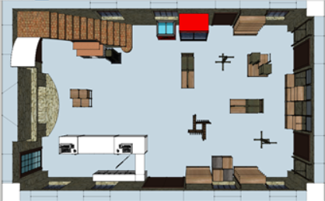

- Brazell’s Creek Golf Course hosted a golf tournament in which 32 different 2-person teams participated.

- Laura Walker Park held a “Happy 76th Birthday” to Smokey Bear. This is an annual partnership with LSW and Georgia Forestry Commission. The two agencies working very close together for events and resource management. The party ended with an amazing show by Georgia Forestry Firefighting plane performing a water drop for all the park visitors over Lake Laura Walker.

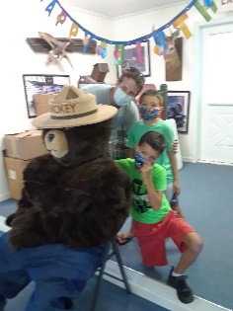

- At Mistletoe, staff used the new tablet at the Kiosk for the first time this weekend. Staff sold over 40 passes with a credit card.
- Work on the new CXT bath house at the Watson Mill Bridge equestrian area continues and should be completed soon.
- Several schools have reached out to Panola Mountain regarding a virtual field trip for this fall. This may be a new opportunity for Parks to assist schools again.
- Demolition has started on cottage 8 and cottage 9 at Red Top Mountain. Cottages 10 and 11 have been dried in and construction continues.
- SAM Shortline Railroad is seeing steady increase in ridership each weekend the train runs.
- August 3, 2020, Reader’s Digest named Skidaway Island State Park the most scenic campsite in Georgia.
- The Sylvania Welcome Center was very busy this past weekend.
- The new footbridge was set in place at Victoria Bryan over Rice Mill Creek. This bridge is replacing the one that was severely damaged in a flood earlier this year.
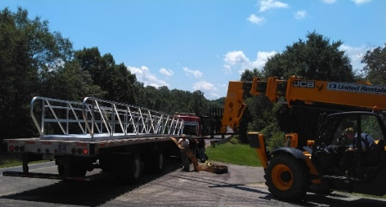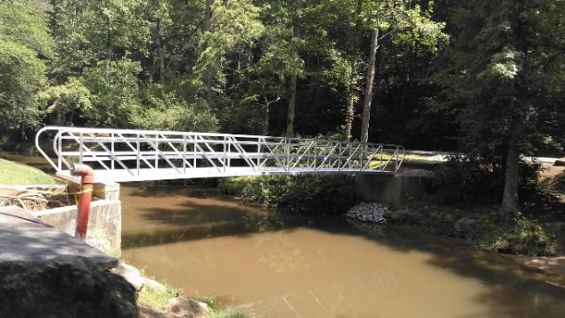

- WTOC-Channel 11 news clip that was recorded a few weeks ago “Exploring Our Parks - Wormsloe Historic Site” aired this week.
- Forbes.com featured Reed Bingham in an article - “Six Underrated Southern Destinations To Include On A Nature Lover’s Road Trip,” Forbes has 91,438,770 unique viewers per month.
- Public Affairs Coordinator, Kim Hatcher was recently interviewed by WLAQ radio from Rome. She promoted James H. Sloppy Floyd, Fort Mountain, and other Northwest Georgia sites.
- The GIS unit has been conducting a full perimeter boundary line inspection and posting around Cloudland Canyon's 3,500 acres. Extensive property deed and plat research and mapping continues and on-the-ground work has begun.
The scribe stone – a rare find!
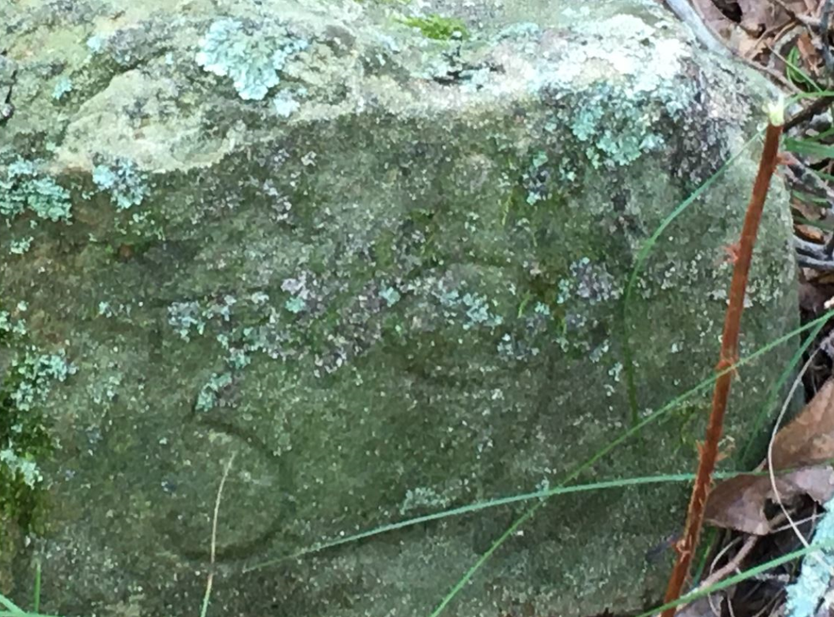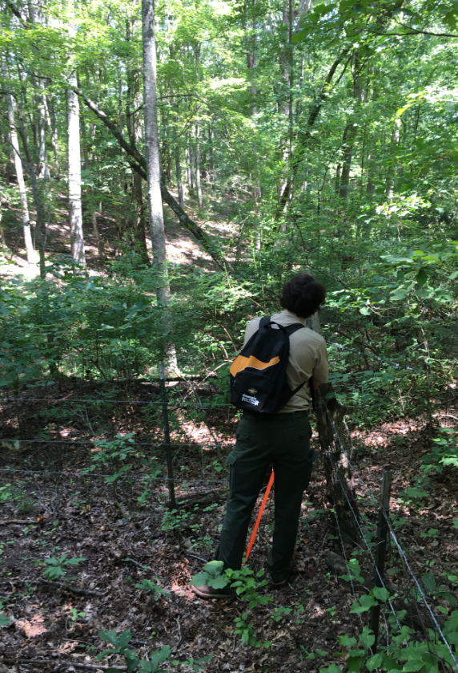

- The construction of the new Skidaway Island Visitor Center continues to progress. The Retail Unit is working on the new building at Skidaway Island, designing it and placing orders for the display fixtures. Photos taken of the construction on August 11, 2020. The inside of the store is inspired by classic southern design and charm including old Savannah brick accents and a live oak tree display.


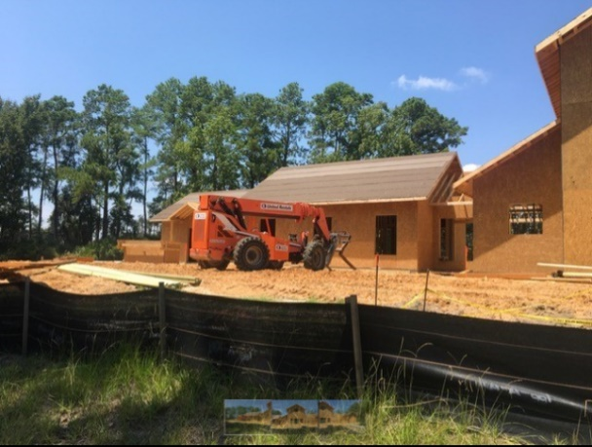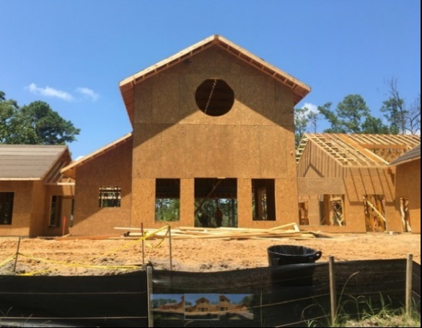

- The following sites were the best-selling Parks and Historic Sites in July for retail.

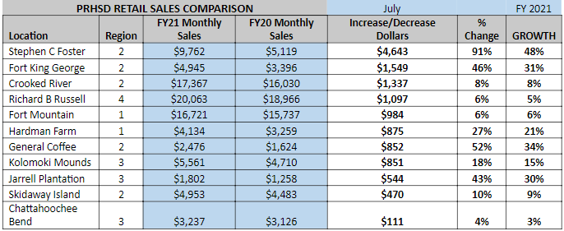

Challenges:

- A Camper’s dog was bitten by a venomous snake at Black Rock, and thankfully will recover.
- Crooked River had drones being flown on the park this past weekend without permission. Also, there was a vehicle collision at the boat ramp reported Sunday after occurring Saturday. The site is trying to retrieve security camera footage.
- Franklin D. Roosevelt had a search and rescue incident of a female hiker that passed out on the trail due to being dehydrated.
- An elderly hiker at Ft. Mountain fell on the stone tower trail and scraped his arm and nose. He refused transport by ambulance.
- Storms at Ft. Yargo toppled several trees in the day-use area and around the trail system, but the cleanup is going smoothly. Two guests (one Saturday and one Sunday) became dehydrated and overheated. Saturday’s guest was transported to the local hospital for care and is now doing well. Sunday’s guest refused treatment and left with family members.
- Guests at General Coffee reported that another camper was abusing their child. LE responded and determined this not to be the case.
- Sites throughout the state at various times lost power, telephone or internet due to thunderstorms over the last week but thankfully no site incurred damages.
- LED wrote a number of citations for alcohol and fishing license violations at Sweetwater Creek this weekend.

Financial Update:

Past Weekend:

Overall occupancy for all reservables significantly increased this past weekend by 12% to 69%. Camping continues to see a significant increase, improving 14% to 79% occupancy. Cottage occupancy also saw an improvement for the 2nd weekend in a row. Cottage occupancy increased 11% to 86%. Yurt occupancy decreased 4% to 91%.

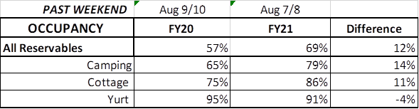

Upcoming Weekend:

For the upcoming weekend, we are seeing a 5% increase in all reservables at 61% occupancy. All overnight accommodations are showing an increase, with camping improving 7% to 71%, cottages improving 10% to 79% and yurts improving 1% to 92% occupancy.
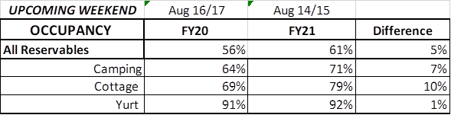

Revenue:
Due to a strong August, for FY21, YTD through August 9th, park receipts have increased 5% or $240,000. For overnight accommodations – All overnight accommodations had a significant increase for the week. Camping revenue improved 51% or $106,000. Cottage revenue increased 24% or $41,000. And Yurt revenue improved 82% or $9,000. For August 3rd – 9th, ParkPass revenue increased a substantial 53% or $46,000 compared to last year. Golf once again had a significant increase, improving 49% or $18,000.

